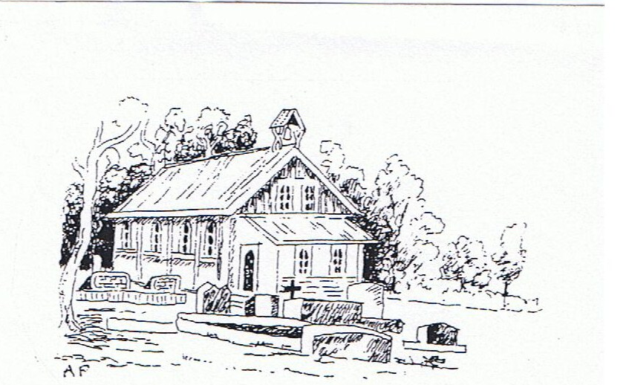

150th Anniversary

7 March 2016
St John’s Matarawa - 1866-2016
Dear Friends of St John’s Matarawa

Registrations are starting to flow in for the 150th celebrations at St John’s church. You will have received a letter of invitation to the event, to be held at the church on No 2 Line at Matarawa and we hope you are planning to attend.

Bishop Justin Duckworth, the Bishop of Wellington, has accepted our invitation to speak at the service of commemoration, which will start at 11 am. The service will be followed by a luncheon at the Fordell Hall on Station Road, Fordell, starting at 1 pm.

If you have already replied and tried to pay by internet banking you may have experienced difficulties. Unfortunately there was an incorrect number given for the banking details. The correct account details are given below. Apologies to anyone who was frustrated by the error.

The cost for the luncheon is $40 per adult and $30 for children 12 years and under. This amount includes a catered country buffet lunch, registration, drinks, tea and coffee. The Fordell School fundraising committee have prepared the menu and will serve the luncheon.
We/they need to know numbers attending for the lunch. We would also like to know if you intend coming to the service only, to ensure adequate seating and song sheets.

Please RSVP by 31 March 2016 to the Treasurer, Brian Shaw, PO Box 109, Wanganui.
Payment can be made online to Friends of St John’s Matarawa 03-0791-0482965-00 (please use your surname and initials as Reference) – or by cheque made out to the Friends of St John’s.

If you have any queries please contact any of the sesqui centennial committee members:
Joy McGregor mcgregor.aird@inspire.net.nz (06 342 7763); Maureen Naldrett-Jays (06 342 7657) pariawa@farmside.co.nz ; Betty Stewart (06 344 7564); Bill Campbell (06 345 0525) patric@xtra.co.nz or Brian Shaw brylyn.deer@xtra.co.nz (06 342 4710).

The banners are up and preparations are under way. We do hope you can join us.

