
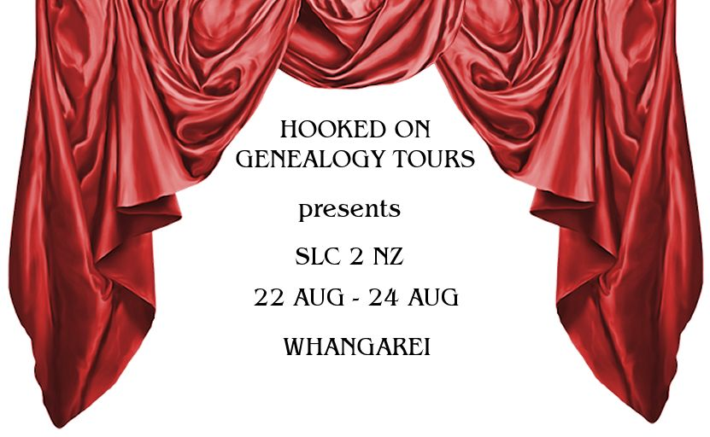

JAN GOW’S
HOOKED ON GENEALOGY TOURS

in conjunction with the
WHANGAREI FAMILY HISTORY COMPUTER GROUP
presents
SLC2NZ – THE PROVINCES
WHANGAREI
22 – 24 AUGUST 2014


Time to research!
Let’s delve into the past and find our ancestors

INFORMATION AND REGISTRATION FORM
Name:
Address:
Email:
Phone: |  | Emergency contact:
Dietary/Special needs

Payment details: Internet or telephone banking preferred.
Bank Account Number: 03 0345 0140498 00
~ ~ ~ ~ ~ ~ ~ ~ ~ ~ ~ ~ ~ ~ ~ ~ ~ ~ ~ ~ ~ ~ ~ ~ ~ ~ ~ ~ ~ ~ ~ ~ ~ ~ ~ ~ ~ ~ ~ ~ ~ ~ ~ ~ ~ ~ ~ ~ ~ ~ ~ ~ ~
Notes:
- Start time Friday 22 August 1.30pm
- Finish time Sunday 24 August 3.30pm
- The weekend is limited to 15 people maximum. Your place will be secured on receipt of your deposit of $150.00.
- The balance of $150.00 is due on check-in.
- Your full payment covers accommodation (twin and multi shared), Friday and Saturday dinner, Saturday and Sunday lunch, morning and afternoon teas, and all research costs.
- Other meal and refreshments are at your expense.
Please complete and return your registration form by 4 August 2014.
Identify your research goals! Return your questionnaire!

Office Use Only | Checked
Payment received
Info entered in database
Questionaire returned
FHL question forwarded
Pedigree Chart received

