Preserving My Grandfather’s Voice
Posted by David Rodeback on July 17th, 2013
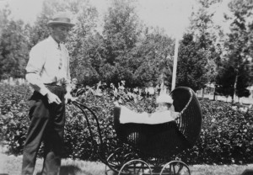
My grandpa and his first son, Shirl
For more than 30 years, a certain cassette tape has moved with me to dormitories, apartments, and homes in two different time zones. It contains the original copy of an interview with a long-deceased ancestor, which makes it precious. For decades I have procrastinated doing anything useful with it, which makes me . . . well, human, I suppose. In case you are human in the same way, I am documenting the recent end of my procrastination in some technical detail.
My paternal grandfather, Noah Rodeback, passed away in May 1983. A year or two before that — no one remembers exactly which year — he visited my family in Moreland, Idaho. I don’t remember whose idea it was to sit him down with a tape recorder, but that’s what we did. I supplied the tape recorder and the tape — nothing fancy in either case — and the tape remained in my possession, so it may have been my idea. In any case, he was a good sport about it, and we got him talking about his childhood, his memories of my father and the rest of the family, and other topics for more than an hour.
We never planned to distribute the tape, just transcribe it. I started that once but never finished. It was slow work, because the recording is of fairly low quality, like the recorder itself, the microphone, and the cassette — which, just to make things worse, I was reusing. I’ve been careful not to lose the tape through several moves, but that’s about all the good I can say.
Cassette tapes make me nervous. The act of listening to one can destroy it, if the player decides to “eat” the tape, or if any of the moving parts of the cassette malfunctions. Dirty recording or playback heads can reduce the lifespan and the quality of the recording. Even if everything is mechanically sound, the magnetic recording and the tape itself can degrade over time; I’ve read that 10 to 20 years is a reasonable lifespan. However, when I looked recently into how one might best preserve a tape, I realized, with a little help from the Council on Library and Information Resources, that I had done some things right, without thinking about it much.
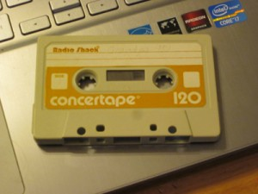
The old cassette
To my knowledge the tape was never exposed to sunlight, unusual heat, or a strong magnetic field. I kept it in a plastic case, which protected it from dust and other substances. For most of the years since it was made, it was stored in a place with low humidity, nine years in upstate New York being the exception. There were some things I didn’t know to do, such as store it upright, instead of lying flat. Fortunately, it survived, though the quality of the recording, already low, might have degraded a bit. (I have no way of knowing.)

RECORDING THE RECORDING
I probably could have found a sound studio to copy the recording and clean it up for me, and maybe I still will, but I wanted to make my own copy anyway for safekeeping. So, I thought, why not take a crack at it cleaning up the recording myself? I’m not claiming procrastination to be a virtue, but now, more than 30 years after the we made the recording, I have a fairly powerful laptop computer with excellent, open-source (as in free) sound editing software, Audacity, with the LAME MP3 encoding add-on, which is also free.
I have some experience editing audio from my occasional ventures into podcasting, among other things. I have an old Optimus stereo cassette playback deck from Radio Shack, which I used to use with a small stereo. I thought about cleaning its heads, but it worked okay with other tapes, I didn’t have a head cleaning cassette handy, and I didn’t want to make anything worse inadvertently by cleaning them manually.
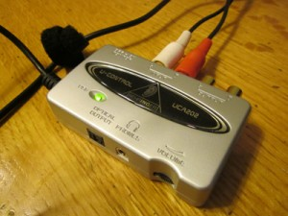
The UCA-202
I ran an RCA cable from the tape deck to a Behringer UC202 USB/Audio Interface, which allows me to connect the laptop to an analog audio source via a USB port. When podcasting, I use this between the laptop and a small mixing console, but I didn’t need the mixing console for this operation. (I used it after processing, to add a spoken introduction to the recording.) Windows 8 was able to recognize and install the software for the UC202 on my new laptop without ceremony.
I hooked everything up and tested the setup with a cassette I don’t care about. For some reason, I want to mention that it was an old Barry Manilow album — blush — from my youth, and not one of the good ones, either. I found it in my dad’s basement this spring.
Then I popped in the precious interview tape and started it running, so I could set the recording level. That done — but not for the last time — I recorded the entire interview with Audacity, monitoring it periodically through some old Sony headphones I wear at the gym. When I listened to the whole digitized recording, I decided that I had set the recording level too low, so I recorded it again. This time, there were several new gaps in the recording, and the level was slightly higher than I wanted.
The new gaps made me wonder if my first run had been the last good one for the old cassette. But I wound and rewound it fully, then tried again. This time, it played without the gaps, and I nudged the level down a bit from the second run. I was pleased with the result.
I worked on noise removal and other editing for a while, then discovered I had made a mistake. I had meant to keep a safe, unedited copy of the third master and work on a separate “work” copy, so I could go back and start over, if I didn’t like where my editing led. I had done this for the first and second masters; it only makes sense. Well, I didn’t like where my editing led, and that was when I discovered that I had neglected to make that safe copy. So I decided a fourth try might be beneficial.
My fourth “digital remaster” — gee, that sounds sophisticated — was the best I could do, I decided. I carefully left a copy untouched for safekeeping and did my editing on a “work” copy.

PROCESSING THE AUDIO
I asked around, did some reading on the web, and discovered that Audacity not only can help with the highly desirable task of removing tape hiss, but is particularly good at it. With the hiss reduced, I could boost the level of the voices, too. My original motive was simply to make transcription a lot easier, but then things went so well that I decided to publish the recording for the family. Burned onto a CD, it will make a nice birthday gift for my dad. (He doesn’t read this blog. If you see him, please don’t mention the gift to him until mid-August.)
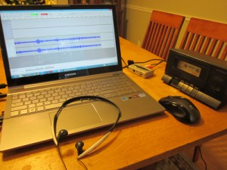
The laptop, tape deck, etc.
The object in noise removal is to remove as much noise as possible, while distorting the voice as little as possible. It’s a judgment call. The voice in this recording is too soft, and I wonder if the hiss has increased over time. In these circumstances I wasn’t expecting miracles, but any improvement would make the transcription easier.
As it turns out, the key is patience — trying different settings on different sections of the recording, to see what might give the best results overall. Just the processing for a single pass takes several minutes. Then listening to judge the effects on the whole 72-minute recording takes a while. Fortunately, Audacity has a very nice “undo” function, so it’s easy to try different settings, compare the results, and quickly go back to the drawing board.
When I was convinced that the noise removal had taken me as far as it could, I ran Audacity’s dynamic range compression function to amplify the soft parts a little and soften the loud parts. Then I edited out a few long silences, mixed in a brief spoken introduction from me to identifying the recording, and exported the recording as an MP3 file. I burned the MP3 onto a few CDs for distribution to my dad and his remaining siblings, and I burned a copy for me onto an archival M-Disk, which shouldn’t degrade anytime in the next 1000 years or so.
If you want to judge the fruits of my amateur efforts, here’s the same 41-second clip before and after my processing. There’s a marked improvement, but you shouldn’t expect miracles either.
If you want to try this at home, here are links to Audacity, the LAME plugin, and instructions for noise removal and dynamic range compression.

THE FUN PART
Next comes the fun part: Delivering to my dad and two aunts and an uncle a recording of their father which they don’t know exists. Then I’ll probably split the recording into shorter segments and upload some of them to my MyHeritage family tree. And I may see what a professional can do to improve the recording.
I suppose I should finally transcribe the recording sometime soon.

