
Whangarei Family History Computer Group

Contacts:
Gloria: 022 635 4161barryandgloria33@gmail.com
Wayne: 437 2881 wayne@bydand.co.nz
Pat: 437 0692 whangareifamilyhistorygroup@gmail.com

Contents:
Calendar dates
Venues
Websites, Information and Newsletters
For Sale
Calendar dates 2014
Thursday Eve Saturday Morn
May 8 May 17
Jun 12 Jun 21
Jul 10 Jul 19
Aug 22/23/24 SLC2NZ WITH JAN GOW
Sep 11 Sep 20
Oct 9 Oct 18
Nov 13 Nov15
Dec Christmas breakup on Saturday

Venues
Thursday evening 6 Augusta Place Whau Valley. 7.00 - 9.00 pm
Saturday meetings in SeniorNet rooms in James Street. Rooms open at 9.00 and we finish by 1.00pm

$2.00 each meeting or $20.00pa.
Lessons
April’s Thursday eve meeting didn’t have a formal topic and so we went ‘travelling’ with Gloria around the Hokianga area. We were waiting for the meeting to start and it was mentioned that we had taken a trip around the West coast to see Waipoua‘s Tane Mahuta, Nelson’s Kaihu Kauri etc. We hadn’t had time to go over on the ferry to see the Boatshed café and that is when Gloria went onto Google Maps and toured us through the area. There were several family stories from this trip and a few in the room had a family connection with the area.

30th April is the trip to the Auckland Library and the Archives so we went over a few of the details of the trip. (No pre booking for records we want to look at yet and as time is getting on, if there is anything anyone may want looked up and perhaps purchased, email to this address if you aren’t able to make the trip).

There is 1 space left in the two cars going down.
~~~~~~~~~~~~~~~~~~~~~~~~
Saturday morning 19th April, we went over what it is possible to access at the Archives and just what you may find on a Will or Land Record etc that you weren’t expecting. Gloria has previously found an ancestor named in a Will probated after death in the 50s but the person named in the Will had died back in the ‘20s. A name she wasn’t expecting to find.

I found a divorce application in my family and I also found an item of jewellery in a Will, fully described and bequeathed to a friend of the deceased, which was eventually given to my Paternal Grandmother, who then melted it down and made into rings and divided up between her Grand-daughters. I received one of the rings and knew it had come from a bequeathed bracelet and now I know more family details.

Today we also discovered you can put in a town or street name and searchable documents come up in the index. The land record books are huge and will be extremely interesting. Angela has had a chance to look at these on one of her visits. The website is: http://www.archway.archives.govt.nz/ and then enter the name you want.

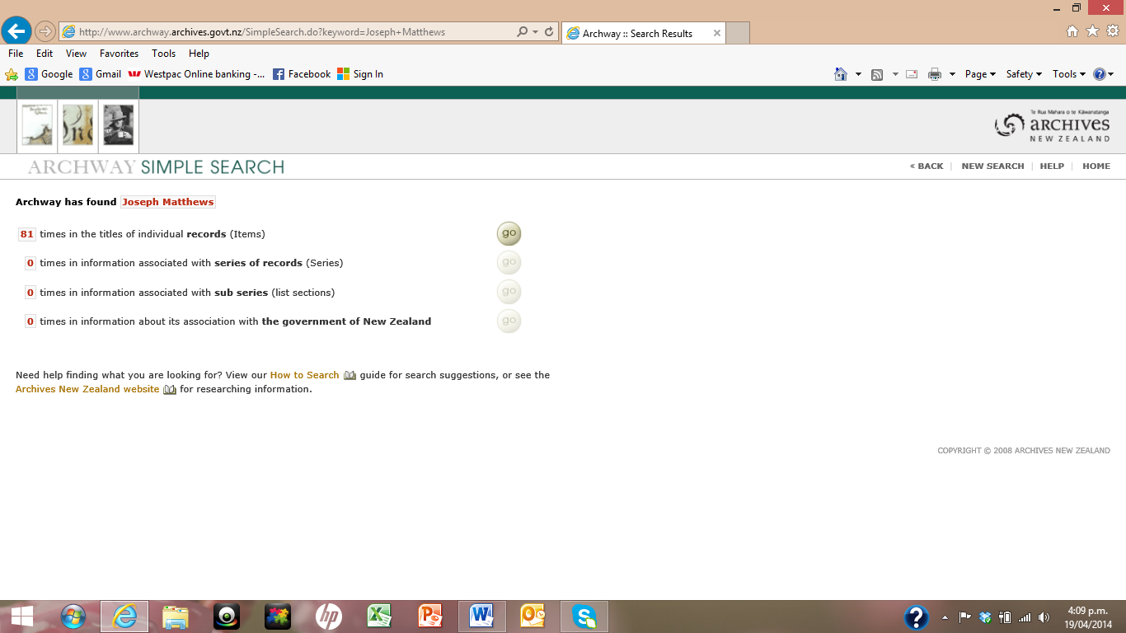
Click “go” and the next page (below) will come up and to the right is “Refine Search” click on this button for the option to narrow date and/or place to make the search a little easier. Note also the 3 options with Green, Orange and Red stripes; each entry has one of these stripes beside the record and so you know if you will be able to view these records or not.
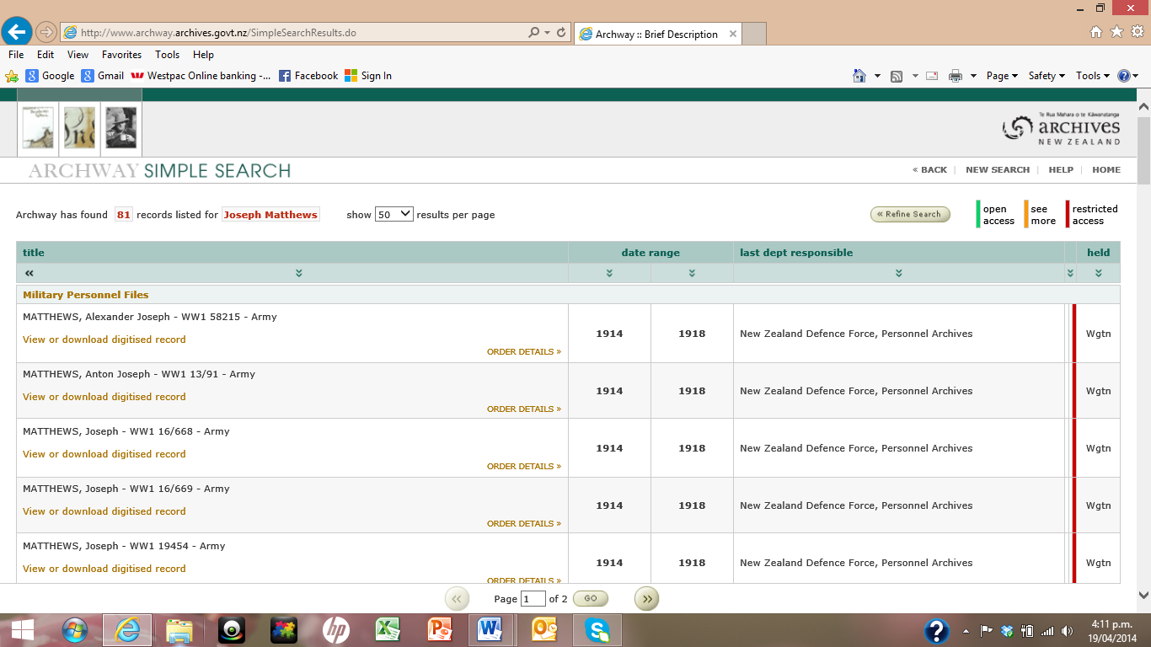

‘‘‘‘‘‘‘‘‘‘‘‘‘‘‘‘‘‘‘‘‘‘‘‘‘‘‘‘‘‘‘‘‘‘‘‘‘‘‘‘‘‘‘‘‘‘‘‘‘‘‘‘‘‘‘‘‘‘‘‘‘‘‘‘‘‘‘‘‘‘‘‘‘‘‘‘‘‘‘‘‘‘‘‘‘‘‘‘‘‘‘‘‘‘‘‘‘‘‘‘‘‘‘‘‘‘‘‘‘‘‘‘‘‘‘‘‘‘‘‘‘‘‘‘‘‘‘‘‘‘‘‘‘‘‘‘‘‘‘‘‘‘‘‘‘‘‘‘‘‘‘‘

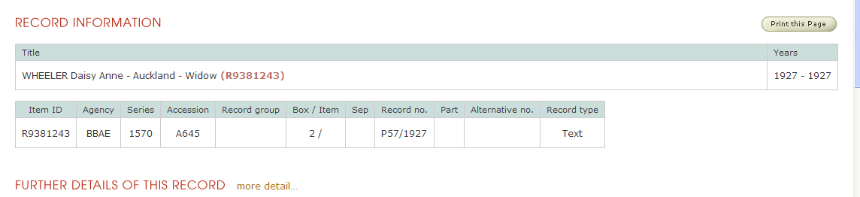
This page will allow you to narrow the search to a geographical area, eg Auckland, and a date range. If it is a Will check the date of death so that records before that date won’t be shown. There may of course be records in repositories in Wellington but they are not available to view in Auckland. When you have found the record you want, copy and paste the record details as below and I can then email the Archives with the details of the record you wish to look at using my reader’s card. They should then be waiting for you to look at and get copies if you wish. For those who aren’t able to go but would like records looked at I am happy to view and find out costs.

Newsletters
(English Archives)This month is on Crime and punishment. Go to the National Archives and search Crime, Prison and Punishment for records dating 1817 to 1931, Searchable by name. The index will take you to findmypast.co.uk. (Available to view the index of records at the Whangarei Library)

Photographs of prisoners on the National Archives site 1872-1873 series (PCOM2/290 and PCOM 2/291)

Also available online is a series of records from MI5 files. Was there a secret agent in your family (KV 2)?

2014 Archives are remembering and honouring WW1 so there is the Archives newsletter First World War portal at: http://enews.nationalarchives.gov.uk/MAN-2CZ3S-4W8575-10QO88-1/c.aspx to help you find out more about the people, events, battles and politics of this conflict. (Should be able to right click on the e-address to go direct otherwise copy and paste)

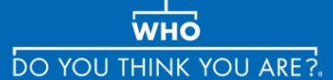This month in Who Do You Think You are newsletter: Northern Ireland birth, marriage and death records now online. The official launch was 9 April. Available at: http://nidirect.gov.uk/family-history

(I have never found an Irish site straight forward to research but perhaps if there is enough interest we can have this as a one of the lessons.)
Also:
Over 500,000 new parish records hit TheGenealogist
The family history website has expanded its parish record collection to include new entries from Essex, Kent, Leicestershire, Monmouthshire and Worcestershire.

Famnet Newsletter
Colleen the new editor of the FamNet newsletter is due to publish the new edition so keep an eye on the FamNet news.

Lost Cousins newsletter (How many like or dislike the new Find My Past World site. I for one didn’t find it very user friendly and much preferred the individual English, Irish or the downunder site. However, in the last Lost Cousins newsletter the editor has very kindly done an `easy to use map’. See attachment 3 PG)

(Other headlines in his latest newsletter)
Post-1858 wills to cost 66% more
Budget could lead to Ancestry price hike
Ancestry add Manchester non-conformist records
Top genealogist backs BMD petition
London Gazette site update causes problems
Findmypast's new site - mismanaged or misunderstood?
Shropshire parish registers online soon
Land Registry publishes 1862 registers
Preserving property deeds
1841: when minors were miners
My ancestors were... not on the census!
Historical directories free online
Message in a bottle
Why did people fear the Victorian workhouse?
British Library's extensive World War 1 resources
Did your military ancestor have "distinguishing marks"?
British Newspaper Archive slashes cost of monthly subscription
Peter's Tips
http://www.lostcousins.com/newsletters/easter14news.htm

Other Websites
Irish Wills index which is online covering the years 1858 to 1920 can be found at: http://www.willcalendars.nationalarchives.ie/search/cwa/index.jsp (Attachment #2 has directions)

PapersPast http://paperspast.natlib.govt.nz/cgi-bin/paperspast
This week I had a session on using this website and have had some wonderful finds on my Matthews relatives.
I did feel that some of the family were rather overshadowed by The Reverend Joseph Matthews. Wonderful events in the announcements such as marriages and births so often had the mention that they were the descendants of Rev Joseph even if they were in-laws of the said gentleman. However, for me looking for information it has been a boon because I am able to build up more family stories about that particular branch of my family.

More newspapers are being added each week and World events, such as the death of the Albert,Prince Consort are written up in our own newspapers so perhaps it is worth those who say “I don’t have ancestors in NZ” to put in names and events they are searching for. There may be a snippet found.

The miserable wet night last week I feel was well spent churning through these pages.

FindMyPast also has a wide range of smaller provincial newspapers on their website so might be worth searching and perhaps purchasing a 1 month subscription once indexed names have been noted to make the most of the month.


Today, many will be remembering those who went to World Wars 1 and 2, and the more recent ones with sadness and gratitude for those who lost their lives and those we were lucky enough to have returned home to us.

PG

